**COMP-2702 – Data Management  
Final Project Proposal**

**Data Analyst’s Name: Tiago Ferreira Saraiva**

**Project Name: Commodities Prices Trends**

**Project Date: 2024-04-05**

1. **Project Description:**
2. Agricultural commodities are vulnerable to weather events, and some common grocery products had changes in their prices over last years. For this project we are focusing on cocoa, coffee, and orange. Which countries are the biggest producers of these products, and what was the price change and volume of stock exchange between 2000 and 2020. Also, what are temperature trends to these countries, do you see them impacting these products prices in the future?
3. Weather events always impacted yields, with climate change such event occurrences are becoming more usual and severe. Don’t want to draw many conclusions because this would need much more research and knowledge, and there is no time to do it, so we want to show visuals with product prices, volume of exchange in the stock market (which is in data set, along time). For land temperatures there is more than hundred years of data for some countries, so we can draw a trends with average temperatures, specific for the countries that are known as the biggest producers.
4. **Business Case**
5. This project intends to bring in some information about agricultural production on three products considered commodities, see how their stock prices evolves along time, and get some insights from average temperatures, knowing that the general weather conditions have direct impact on food production. This information can be useful when discussing future trends on the price of these three products and their bump on grocery prices, as informative panel for news headlines, for people who invests in commodities stock market, for high school students discussing geography.
6. There are three data sets for this project. One is called Global Land Temperatures, from this data set we are using land temperatures by country and by state, so we can include map visuals. Another data set is Commodities, and we are going to use tables coffee, cocoa, and orange juice, with their stock prices by date, with highs and lows, including volume. The last data set is from World Food Production, with some agricultural production volume by year and country, so we can correlate then by date and country.
7. Chose this project because subjects related to politics and people daily life relates to me, and I am looking forward to furthering my knowledge in climate change in future and which ways are governments going to take to mitigate – or not to tackle in some cases, this problem.
8. All data were taken from Kaggle website, as follows:
9. Climate Change Earth Surface Temperature Data: <https://www.kaggle.com/datasets/berkeleyearth/climate-change-earth-surface-temperature-data/data>
10. Agricultural Commodities Futures Data: <https://www.kaggle.com/datasets/guillemservera/agricultural-futures>
11. ~~World Food Production:~~ [~~https://www.kaggle.com/datasets/rafsunahmad/world-food-production~~](https://www.kaggle.com/datasets/rafsunahmad/world-food-production)
12. World Food Production: <https://www.fao.org/faostat/en/#data/QCL>
13. **Business Rules/Assumptions**
    * One country can have many states.
    * One state can have many temperatures.
    * One country can have many commodities.
14. **Entity Relationship Diagram (ERD)**

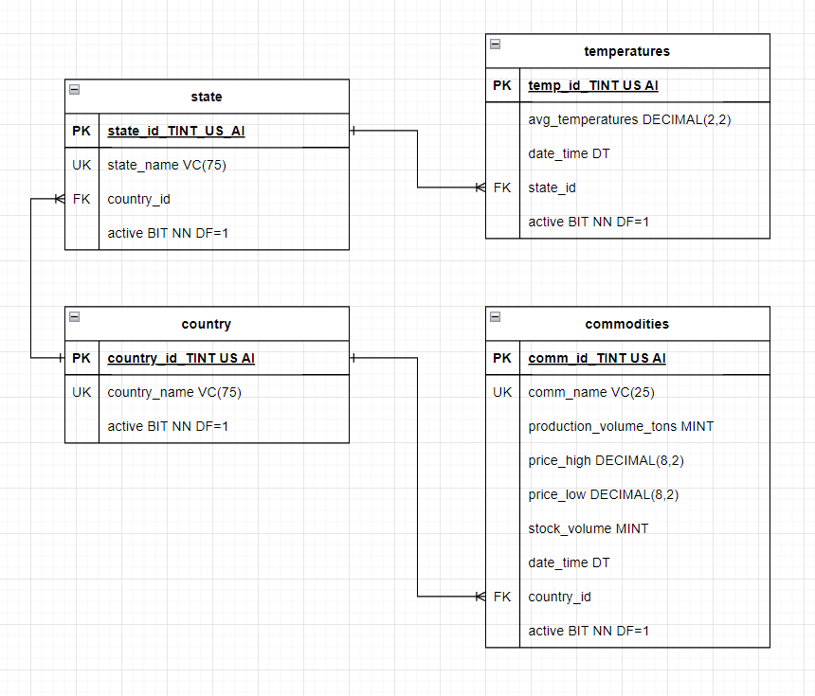

1. **Power BI Dashboard**

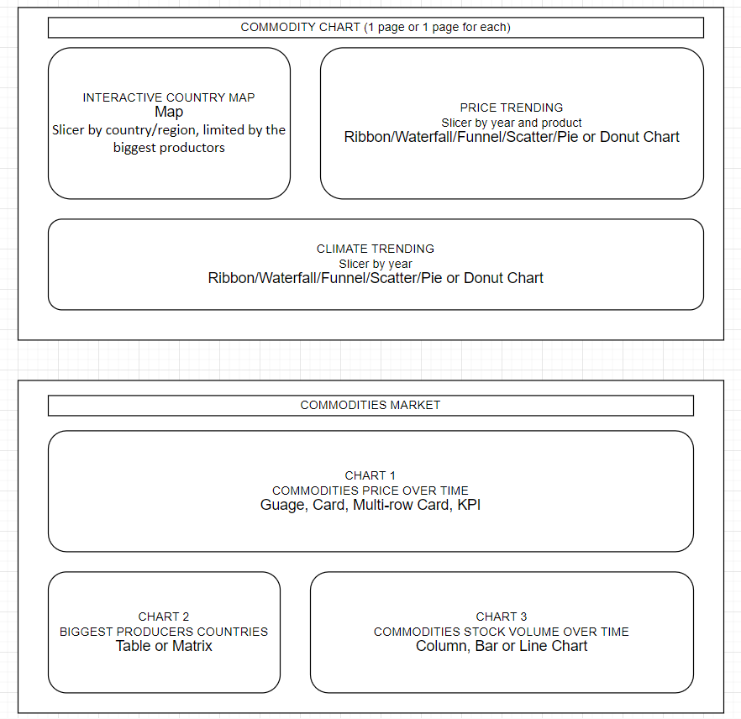

**Annexure**

1 - Included World Food Production data set to the project.

2 – Changed World Food Production data set, getting data directly from FAO website.

3 – Made two unique keys tables with countries and commodities to connect with other tables.

4 – Changed a bit the format from the plan that is here for the visuals, in the end we got a table, a multi-row-card and a ribbon chart alongside with two slicers in the first visual, and in the second visual page we got a map, a line chart and the downloaded chart, with another slicer.